Models for trade idea generation and screening

**Trading Strategy: The Manual**

**Revisions**

|  |  |  |  |  |
| --- | --- | --- | --- | --- |
| Rev. | Date | Author | Description | Approved by |
| v.1.0 | 20/07/2012 | Nimrod Eshed | First Draft from Original Document created by Christos Papathanassiou |  |
|  |  |  |  |  |

1 Introduction 4

2 General description 6

3 Run Analysis 6

3.1 Run single analysis 6

3.2 Run detailed analysis 9

4 Reports 10

4.1 Run reports 10

4.2 Screen reports 10

5 Technical Analysis 10

5.1 Real/Implied vol 10

5.2 Large movement 11

5.3 Volatility surface 11

5.4 Custom weights 12

5.5 PCA analysis 12

5.6 CIX analysis 13

5.7 Plot breakpoints button 14

5.8 Jump Analysis 15

5.9 Granger Causality Test 17

5.10 Multimodal and MultiRW analysis: 18

6 Screenshots 18

# Introduction

This document outlines the design and architecture of the Trading Strategy tool. Trade idea identification is a bottom-up quantitative process using the models, with selection being subject to a qualitative overlay from the user. The screening process will indicate the level of mispricing, measured in standard deviations, of a particular relative value trade idea, and the statistical significance of such an observation.

Detailed screens are used to apply statistical measures to historic data to run analysis into the potential trade and to estimate a number of return characteristics, e.g. return on capital, volatility, time horizon, tail risk etc. While the systems will generate estimated values for all variables, some of the inputs are subjective.

The system is developed under Matlab © and is also utilizing publicly known Statistical methods. The application has an Excel Interface module to facilitate the use and manipulation of input and output data.

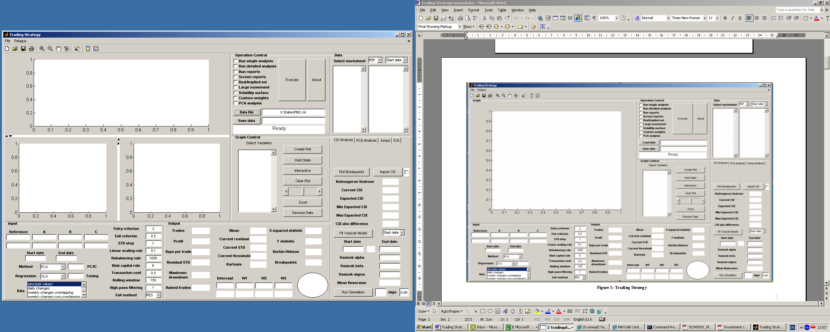

Figure 1: Trading Strategy

# General description

An overview of the Trading Strategy software is given in . The tool is divided in several panels, namely

* **Operation Control**: to perform a particular function.
* **Data**: to select instruments and dates.
* **Graph Control**: to manipulate the graphs.
* **Graph**: where the desired graphs are plotted.
* **Input**: where the essential input parameters are entered.
* **Output**: where the analysis results are displayed.
* **PCA Analysis**: to identify the most tradable factors, proxy for the 1st and 2nd PCs.
* **CIX Analysis**: to fit the Vasicek model on the CIX and run a breakpoints analysis
* **Jump Analysis**: to identify jumps in the data series.
* **Granger Causality Test:** helps if you want and answer to :”Eur = beta*USD or US=Beta*EUR?”
* **Multimodal and MultiRW analysis:** clear overview of the stability of the parameter across different time Horizon/regression type

Each panel performs a specialised function. Their role will be presented in detail below.

First we have to load the data, say JPMorgan data, by pressing the “Data file” button in the “Operation Control” panel. The data are stored in an excel file. A message box acts as a progress bar and displays the worksheet being loaded. The loading process can last up to a minute and has to be performed once. If you need to add an extra data source, for example Bloomberg data, then repeat the process. Note that each time you perform this process, you effectively add data to the existing data space. Therefore, it is appropriate only when you load data from different sources. If you need to clear your data space, perhaps to upload the new data file at the beginning of the day, then press the “Data file” button but then select “Cancel” and all data are unloaded. Then you can start loading the new data file.

In general, the message window in the “Operation Control” panel provides useful comments about the current status of the application (including error messages).

# Run Analysis

## Run single analysis

Once the data are loaded, select the “Run single analysis” checkbox in the “Operation Control” panel. Then you have to provide the data tickers in the “Input” panel. For that purpose, click on the “Select worksheet” list box in the “Data” panel and select the worksheet of interest. Then click on the right hand list box and pick the ticker of interest. Click on the popup menu on top of the list box and select “A”, “B”, “C” or “REF”. This action will copy the ticker to the appropriate field of the “Input” panel. Repeat the process as many times as required. You need at least REF and A to be available. Finally, select the “Start date” and “End date” by clicking the respective popup menu in the “Data” panel. The popup window provides you with a mini calendar. Do NOT select a weekend date or a Bank Holiday. Unfortunately, Bank Holidays are not marked in the calendar popup. This action will copy the desired dates to the respective fields in the “Input” panel. Note that you can bypass the abovementioned procedure if you are confident about the tickers and valid start/end dates and type the values directly in the “Input” panel.

Next step is to select the method you would like to use to explore potential relationships. Use the respective popup menu in “Input” to pick one of the following: PCA (Principal Component Analysis), ICA (Independent Component Analysis), Regression, PCR (Principal Component Regression), PLS (Partial Least Squares Regression). If you have opted for Regression, you may further specify the type of regression you would like to perform. The default is “OLS”. You may opt for a robust multilinear regression, such as “Andrews”, “Bisquare”, “Cauchy”, “Fair”, “Huber”, “Logistic”, “Talwar” or “Welsch” regressions. The number next to the regression type in “Input” is the tuning constant which is used to specify how aggressive against noise the regression is. The default tuning constant gives coefficient estimates that are approximately 95% as statistically efficient as the OLS estimates, provided the response has a normal distribution with no outliers. Increasing the tuning constant decreases the downweight assigned to large residuals. Then pick the data type, namely “absolute values”, “daily changes”, “weekly changes overlapping” or “weekly changes non-overlapping”.

PCR and PLS reduce the dimensionality of the system. Therefore in practice if you select PCR or PLS, then you have to specify the number of components you would like to keep for analysis in the “PC/IC” box in the “Input” panel. If the box is left empty (or when you enter in “PC/IC” the number of predictors), then all components are considered and therefore you should get identical results to simple Regression. Try to reduce your components by one (or even two when you have three predictors) to see different behaviour. The current version does not provide T-statistics for PCR or PLS. It does provide though the R2.

The final step is to specify the remaining input parameters in the “Input” panel. These are:

**Entry criterion**: multiplier of standard deviation (SD), it used to signal a trading opportunity when exceeded by dislocation.

**Exit criterion**: multiplier of SD, triggers exit of an existing trade.

**STD step**: multiplier of SD, it is used to specify rebalancing levels.

**Linear scaling rule**: indicates the amount we should increase our initial stake during rebalancing.

**Rebalancing rule**: currently inactive rule

**Risk capital rule**: the max amount we are willing to risk during the lifecycle of a trade

**Transaction cost**: cost of entering/exiting/rebalancing a trade.

**Rolling window**: length of the time period used in our model to assess a relationship.

**High-pass filtering**: used in large movement analysis to identify extreme positive/negative changes.

**Exit method**: You may select “RES” (default) or “CIX” to determine a trade exit based on the current residual or CIX level respectively.

If all are set correctly, then press the “Execute” button. Depending on the length of the time period you have chosen, the analysis may take some time. For faster results, especially when you are interested mainly in the current status of the relationship and/or the recent past, consider a shorter time period by selecting a more recent start date.

When the analysis is completed, the traffic-light type indicator in the “Output” panel will provide an immediate answer to the question whether this relationship is interesting. Green means that the current residual is a trade entry point according to the entry criterion set previously. Red means that the trade should be rejected. The characteristics of the relationship are provided in the “Output” panel (see ). In particular, you are provided with the following information:

**Intercept and Weights**: Intercept and weights of regression/PCA.

**T statistics**: T statistics of the respective intercept/weights.

**Trades**: Number of trades executed during the assessed time period.

**Profit**: Total P&L for the assessed time period.

**Days per trade**: Average number of days per trade

**Residual STD**: The standard deviation of the residual for the assessed time period.

**Maximum drawdown**

**Ruined trades**: Number of trades which we forced to close due to exceeding the risk capital rule.

**Mean**: Mean level of the residual over the assessed time period (for a mean reverting process it should be close to zero)

**Current residual**: The current dislocation.

**Current STD**: The current standard deviation used for entry/exit purposed based on the specified rolling window.

**Current threshold**: Entry level threshold.

**Kurtosis**

**R-squared statistic**: Indicates how good the model describes the relationship

**F statistic**

**Durbin-Watson**: statistical test performed on the vector of the residuals from a linear regression. It is used to test whether the residuals are independent or there is autocorrelation among them.

If you press “Save data”, you may save the abovementioned results including a detailed analysis of the relationship in an excel file.

The program allows plotting the results in the “Graph” area by using the tools in the “Graph Control” panel. Click the list box in the “Graph Control” to get the complete list of variables that can be displayed and then select the variables you would like to plot. Hold Ctrl if you want to plot more than one variable. For example, you may plot the residual and the CIX on the same graph (see , residual: blue, CIX: red). A popular graph is given in . It depicts the history of the relationship under examination. An entry point is denoted by a green dot; an exit point is denoted by a red dot, whereas a rebalancing point by a yellow dot. The green and red upper and lower band lines depict the entry and exit thresholds. You may see the details of the relationship for a particular date if you click the “Interactive” button in the “Graph Control” panel and then on the graph displayed, such as the level data and the residual for that date. You may further manipulate the graph by zooming in and out, or plot additional STD bands by moving the slider in the “Graph Control” area to determine the current dislocation level. The plot area is cleared automatically each time a new analysis is performed. Note that the “Graph” area provides three different plots at the same time. The lower right graph (see ) always provides the raw data used for the analysis displayed in different colours. The upper graph depicts the outcome of the analysis. The lower left graph is reserved for PCA analysis. When you move the cursor over a graph, you see a vertical line which indicates the exact date position in all three graphs. Also if you keep any mouse button pressed over a graph, then you get a yellow box with the vital details for that particular date (such as raw data and residual). Note that you can always use the Interactive button for more accurate browsing over different dates.

## Run detailed analysis

Select the “Run detailed analysis” checkbox in the “Operation Control” panel. The user may use multiple values in the “Entry criterion” (EC), “Exit criterion” (XC), “Risk capital rule” (RCR) and/or “Rolling window” (RW) fields of the “Input” panel (separated by commas). Provide a file name in the “Save data” field of the “Operation Control” panel and then press “Execute”. The program will run all possible combinations of EC/XC/RCR/RW and will store the analysis results in the excel file (namely, number of trades, days per trade, number of ruined trades, max ruined trade P&L, number of losing trades and max losing trade P&L).

# Reports

## Run reports

Select the “Run reports” checkbox in the “Operation Control” panel. A pop-up window asks the user to select the report instruction file. This is a plain text file which states the directories (full path) containing the respective report excel files.

## Screen reports

Select the “Screen report” checkbox in the “Operation Control” panel. The “Graph” panel is now replaced by the “Screening” panel (see green box in ). First, click the “Report Instructions File” button and select the text file which states the directories where the report files reside. Then click “Load” to load the actual reports. Depending on the kind of reports you are about to screen a different panel may appear. In particular, if the reports are NOT about realised volatility then the user gets “Screening Parameters 1” panel (see red box in ), otherwise he gets “Screening Parameters 2” (see blue box in ). Set the screening thresholds as required using the sliders and press “Screen”. The screened reports may now be seen in the “Screening Output” panel (note that the screening process may take up to a minute). The total number of screened reports is next to the “Copy” button. When you scroll the list of screened reports, you may see their details (namely, weights/intercept and data tickers). When you press “Copy”, you transfer the data tickers to the “Input” panel so you can perform further analysis (such as single analysis for example).

# Technical Analysis

## Real/Implied vol

Select the “Real/Implied vol” checkbox in the “Operation Control”. Enter the data tickers as usual and then the respective implied volatility data tickers in the second line of inputs in the “Input” panel (encircled in red in ). Press “Execute”. First the data are converted to returns. Then we estimate the parameters of a GARCH(1,1) process. In particular, the conditional standard deviation vector corresponding to the residual time-series vector inferred from the returns data is used to compute the realised bpvol. Then we calculate the realised bpvol ratio and the implied vol ratio over “Reference”. The results are now automatically depicted in the “Graph” panel (blue for realised vol ratio, red for implied vol ratio). If we have not provided a file name in the “Save data” field of the “Operation Control” panel, the function is terminated. Otherwise, we perform a full single analysis (as abovementioned) and the results are stored in an excel file. We may select more than one data type (by holding Ctrl when selecting data types) and more than one rolling windows (separated by commas in the “Rolling window” field of the “Input” panel). The excel file contains a series of worksheets. The “RESULTS” worksheets present detailed single analysis, and are typically named as “RESULTS_x_y” or “RESULTS_IMPL_x_y”, where IMPL: implied volatility data, x: data type (1: level data, 2: daily changes, 3: weekly changes overlapping, 4: weekly changes non-overlapping) and y: size of rolling window. The “SUMMARY_BETA” worksheet presents the current values of weights/intercept and implied/realised ratios for each combination of data type and size of rolling window. Finally, the “SUMMARY” worksheet presents useful statistics for each combination such as CIX min/max/mean/std/skewness/kurtosis and min/max/mean/std of weights.

## Large movement

Select the “Large movement” checkbox in the “Operation Control”. The “Output” panel is replaced by the “Large Movement Analysis” panel (encircled in red in the figure below). The selected data type in the “Input” panel should be different from “absolute values”. The transformed data (i.e. “daily changes”, “weekly changes overlapping” and “weekly changes non-overlapping” are filtered using the “High-pass filtering” rule of the “Input” panel. In particular, all data which are higher than a multiplier of the data standard deviation (provided in the “High-pass filtering” field) are considered to be associated with extreme positive moves; those who are less than the negative of that threshold are considered to be extreme negative moves. The remaining data are assumed to be non-extreme. Then we perform regression on each category of the filtered data and present the results (namely, the weights/intercept/R2) in the “Large Movement Analysis” panel.

## Volatility surface

Select the “Volatility surface” checkbox in the “Operation Control” and press “Execute”. The program processes in order all available currencies, namely JPY, GBP, EUR and USD. We form a table which includes all possible combinations of expiry and tenor for the volatility:

1M1Y 1M2Y 1M3Y 1M4Y 1M5Y 1M10Y 1M12Y 1M15Y 1M20Y 1M30Y

3M1Y 3M2Y 3M3Y 3M4Y 3M5Y 3M10Y 3M12Y 3M15Y 3M20Y 3M30Y

6M1Y 6M2Y 6M3Y 6M4Y 6M5Y 6M10Y 6M12Y 6M15Y 6M20Y 6M30Y

1Y1Y 1Y2Y 1Y3Y 1Y4Y 1Y5Y 1Y10Y 1Y12Y 1Y15Y 1Y20Y 1Y30Y

2Y1Y 2Y2Y 2Y3Y 2Y4Y 2Y5Y 2Y10Y 2Y12Y 2Y15Y 2Y20Y 2Y30Y

3Y1Y 3Y2Y 3Y3Y 3Y4Y 3Y5Y 3Y10Y 3Y12Y 3Y15Y 3Y20Y 3Y30Y

5Y1Y 5Y2Y 5Y3Y 5Y4Y 5Y5Y 5Y10Y 5Y12Y 5Y15Y 5Y20Y 5Y30Y

7Y1Y 7Y2Y 7Y3Y 7Y4Y 7Y5Y 7Y10Y 7Y12Y 7Y15Y 7Y20Y 7Y30Y

10Y1Y 10Y2Y 10Y3Y 10Y4Y 10Y5Y 10Y10Y 10Y12Y 10Y15Y 10Y20Y 10Y30Y

15Y1Y 15Y2Y 15Y3Y 15Y4Y 15Y5Y 15Y10Y 15Y12Y 15Y15Y 15Y20Y 15Y30Y

20Y1Y 20Y2Y 20Y3Y 20Y4Y 20Y5Y 20Y10Y 20Y12Y 20Y15Y 20Y20Y 20Y30Y

Then we split the above table in four smaller tables. Each one describes a particular corner. Let us denote them by UL, UR, LL and LR for the upper left corner, upper right, lower left and lower right corner respectively. The abovementioned table can be split in many different ways (For example, we used different colours to demonstrate a particular configuration of the above table, red for UL, green for UR, black for LL, blue for LR). For each split configuration, we perform PCA on the data of each sub-table. The configuration which produces principal components best explaining on average the variance of the data is the optimal one. Note that the optimisation is a slow process which will take several minutes. For that optimal configuration, we regress the data of each sub-table against the principal components produced by the level data and daily changes of that sub-table. We tabulate the residual of the regression of the level data and the R2 of the regression for both the level data and daily changes in two separate matrices for each sub-table. The process is performed for JPY, GBP, EUR and USD. The results are stored into an excel file whose file name has been provided by the user in the “Save data” field of the “Operation Control” panel.

## Custom weights

Select the “Custom weights” checkbox in the “Operation Control” panel. The program will use the intercept and the weights W1, W2 and W3 which have been already provided by the user in the respective fields of the “Output” panel to calculate a custom CIX. The custom CIX graph can be then displayed if we select “Custom CIX” in the “Graph Control” list box.

## PCA analysis

Select the “PCA analysis” checkbox in the “Operation Control” panel and go to the “PCA Analysis” tab (encircled in red in ). Enter in the “Input” field the variables upon which we will perform PCA separated by comma, say “A1,B1,C1”. Enter in the “Markets” field variables separated by comma, say “A2,B2,C2”. The start/end dates are provided in the “Start date”/“End date” fields of the “Input” panel respectively. By pressing “Execute” in the “Operation Control” panel, we perform PCA on the variables A1, B1 and C1 and we compute the correlation coefficients between the daily changes of the A2, B2 and C2 and the first principal component PC1. Similarly, we compute the correlation coefficients between the daily changes of the differences of the variables, B2-A2, C2-A2 and C2-B2 and the first principal components PC1. We order the two sets of correlation coefficients in a descending order. The first output field corresponds on the correlations between A, B and C with PC1. The second output field presents the correlation coefficients between A-B, A-C and B-C with PC1.

## CIX analysis

The CIX analysis is performed using the “CIX Analysis” panel in the right hand side of the Trading Strategy (encircled in red in ). You may use your own CIX time-series (i.e a CIX time-series which was not generated with the Trading Strategy tool). To do so, click the “Import CIX” button. A popup window will ask you to pinpoint the file which contains the data to be imported. It is a simple CSV file which has two columns. The first column corresponds to the dates and the second one contains the actual CIX data.

First, you have to provide the start/end dates used to derive the characteristics of the Vasicek model to be fitted. Thus, click on the popup menu next to the “Fit Vasicek Model” and select “Start date” or “End date” respectively. Select the desired date from the popup calendar window. As before, avoid weekends and known Bank Holidays. You may bypass this date selection process by typing the dates straight to the appropriate fields in the “CIX Analysis” panel. If you have checked the “Import CIX” checkbox then the dates are taken directly from the imported CIX data. Then click the “Fit Vasicek Model” button. The Vasicek model is fitted to different types of CIX, depending on the data type selected in “Input” panel (such as “absolute values”, “daily changes” etc). The model fitting is an optimisation problem and as such it may take some time to be completed. The characteristics of the Vasicek model (namely, alpha, beta, sigma and speed of mean reversion) are then displayed in the “CIX Analysis” panel.

Once these details are known, you may run a forecast by entering the number of days into the future you would like to simulate and the desired confidence level (default value is 0.95). Then press “Run Simulation” and you will presented in the “Graph” area with the respective plot. You are also presented with the characteristics of the CIX time-series projection such as “Expected CIX” level at the end of the projection, “Min Expected CIX”, “Max Expected CIX”, “CIX absolute difference” and of course the “Current CIX” level. There is also a Kolmogorov-Smirnov test performed on the CIX data and the projected CIX time-series. If the result of the test is 0, then the two time-series are drawn from the same continuous distribution.

## Plot breakpoints button

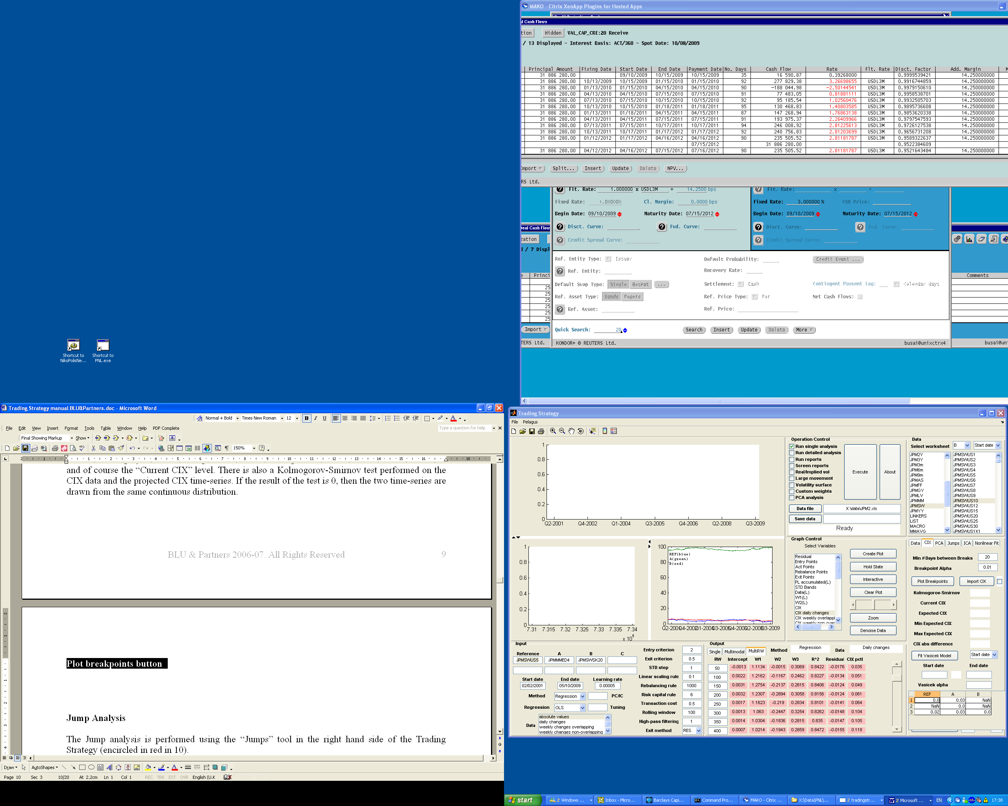

this button allows the user to run a Breakpoint analysis on the plotted CIX by suing a rolling Chow test from the Start Date up to the End date of the Cix. The breakpoint Alpha defines the threshold the user want to use in order to reject or not the null Hypothesis that a break point does not exist (if the F statistic is above the F(1-alpha) then you cannot reject the null hypothesis so a break exist). It is to say the lower the number the lower the probability you would find a break point. The higher the number the higher the probability you’ll find a breakpoint (even if it does not exist!).

The (MDB) Min # Days between Breaks helps the procedure not to try to find breakpoints in a sample with less then MDB*2+1 observations, by default is 20.

The outputs of the analysis are:

If breakpoints exist

1. external small window which contains all the breakpoints dates identified with R^2, stdev, Intercept and Betas of the regression performed within each single subsample. (the type of regression (daily changes/weekly/level) performed within each subsample depends from selected mode on the main Run single analysis screen).
2. On the top left chart all the breakpoint are Highlighted with a yellow spot.
3. A txt file is automatically generated (and continuously updated) on the main drive X: which contain all the information as in 1)

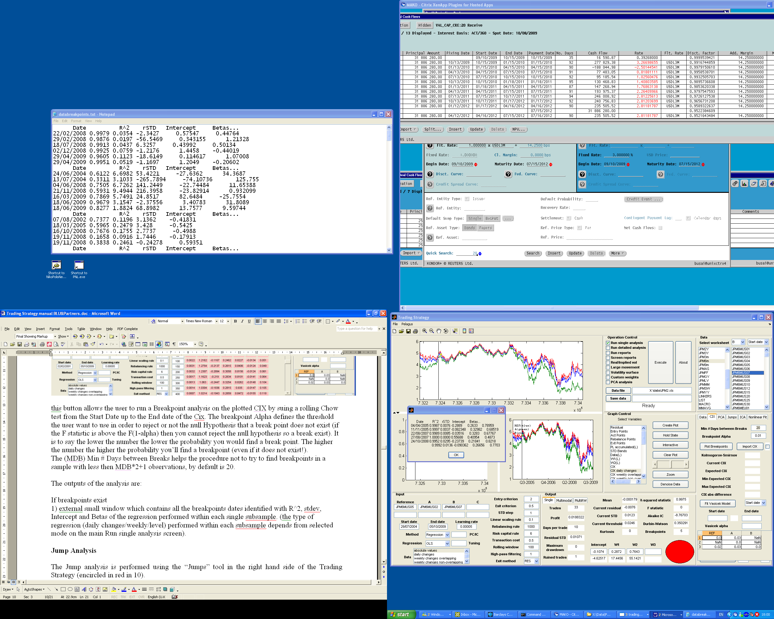

## Jump Analysis

The Jump analysis is performed using the “Jumps” tool in the right hand side of the Trading Strategy (encircled in red in 10).

First, you have to run the single analysis routine and plot the CIX you want to analyze (you can plot every type of CIX Daily/weekly on the top left chart). First, you have to provide the Jump Threshold (2 default) and the Jarque-Brera alpha (0.05 Default) and then press Initialize. If the Jarque-Brera test failed (you will see “Non-Normal” into the Jarque-Brera test box) you have to modify the criteria (increase the Jump threshold or increase the alpha). If the test does not fail you will have “Normal” in the Box and then the system starts to compute some reasonable starting point for the optimization.

Then click on Optimize to start the optimization process. Outputs of the optimization are :

* Alpha (speed of mean reversion)
* Sigma (stdev of the non-jumping process)
* Mean jump size (mean of the distribution of the jumps)
* Sigma of Jumps (stdev of the distribution of the Jumps )
* Jumps (lambda for the Poisson distribution that describes the Jump intensity, probability of a jump between today and tomorrow)
* long term average (the mean reverting level of the CIX)

The starting points box (located on the left of the Optimize one) allows you to run more then once the optimization process by changing the starting points, by default is 1 (keep in mind that the optimization process is quite time consuming).

Once these details are known, you may run a simulation by entering the number of days and number of paths you would like to simulate (bottom right corner) and then press Simulate. On the top left chart you can see the descriptive statistics of the underlying CIX compared with the statistics of the simulated one, this gives you an (visual) idea of the goodness of the fitting.

The expected P&L …(not working at the moment) it is supposed to compute the expected P&L distribution relative to the number of days to simulate.

Save Simulations allows you to save in an excel spreadsheet the outputs of the analysis.

## Granger Causality Test

Granger causality test is a technique for determining whether one [time series](http://en.wikipedia.org/wiki/Time_series) is useful in forecasting another. Input for the test are number of Lag and significance level.

Number of Lag should be chosen according to the type of Var model the user thinks is more appropriate to describe the time series analized. The significance level changes according to the desidered accuracy of the analisys.

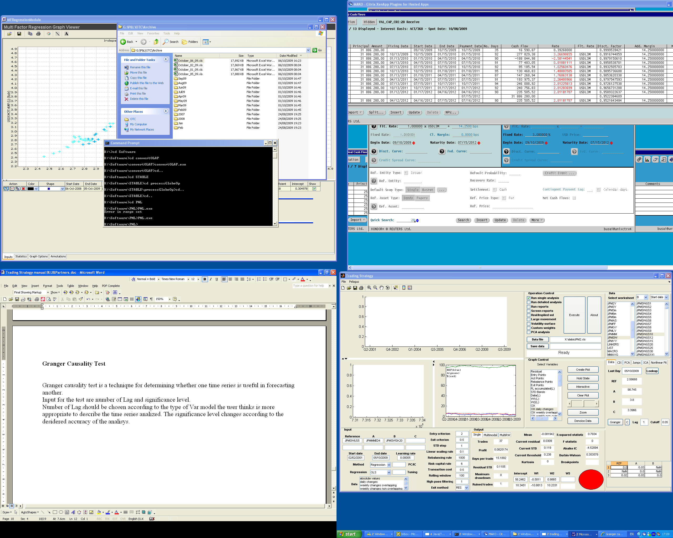

Figure 13: Main Screen

Suppose our dataset consists of 5y USD swap rate 4th ED contract and 20y SEK swap rate.

We select the variables, we run the usual single analysis and then we select the number of lag and the cut off threshold from the Granger analys tool into the Data Subscreen.

The we press Granger and the output will be released into the window on the bottom right corner of the window.

In the above example the output is quite intuitive.

* NaN means that there is no significant impact between the couple selected (according to the selected cutoff point).

So it is to say that from the above example we can say that

* Ref does not have impact on ED4 (makes sense)
* Ref has an impact on SK20 (makes sense)
* A has an impact on US 5y and SK20 (makes sense)
* B does not have an impact neither on A nor on Ref (makes sense)

## Multimodal and MultiRW analysis:

In the Ouput Subscreen there are 3 options available Single (explained above) Multimodal and MultiRW.

# Screenshots

In the following pages we present some screenshots of the concepts described above

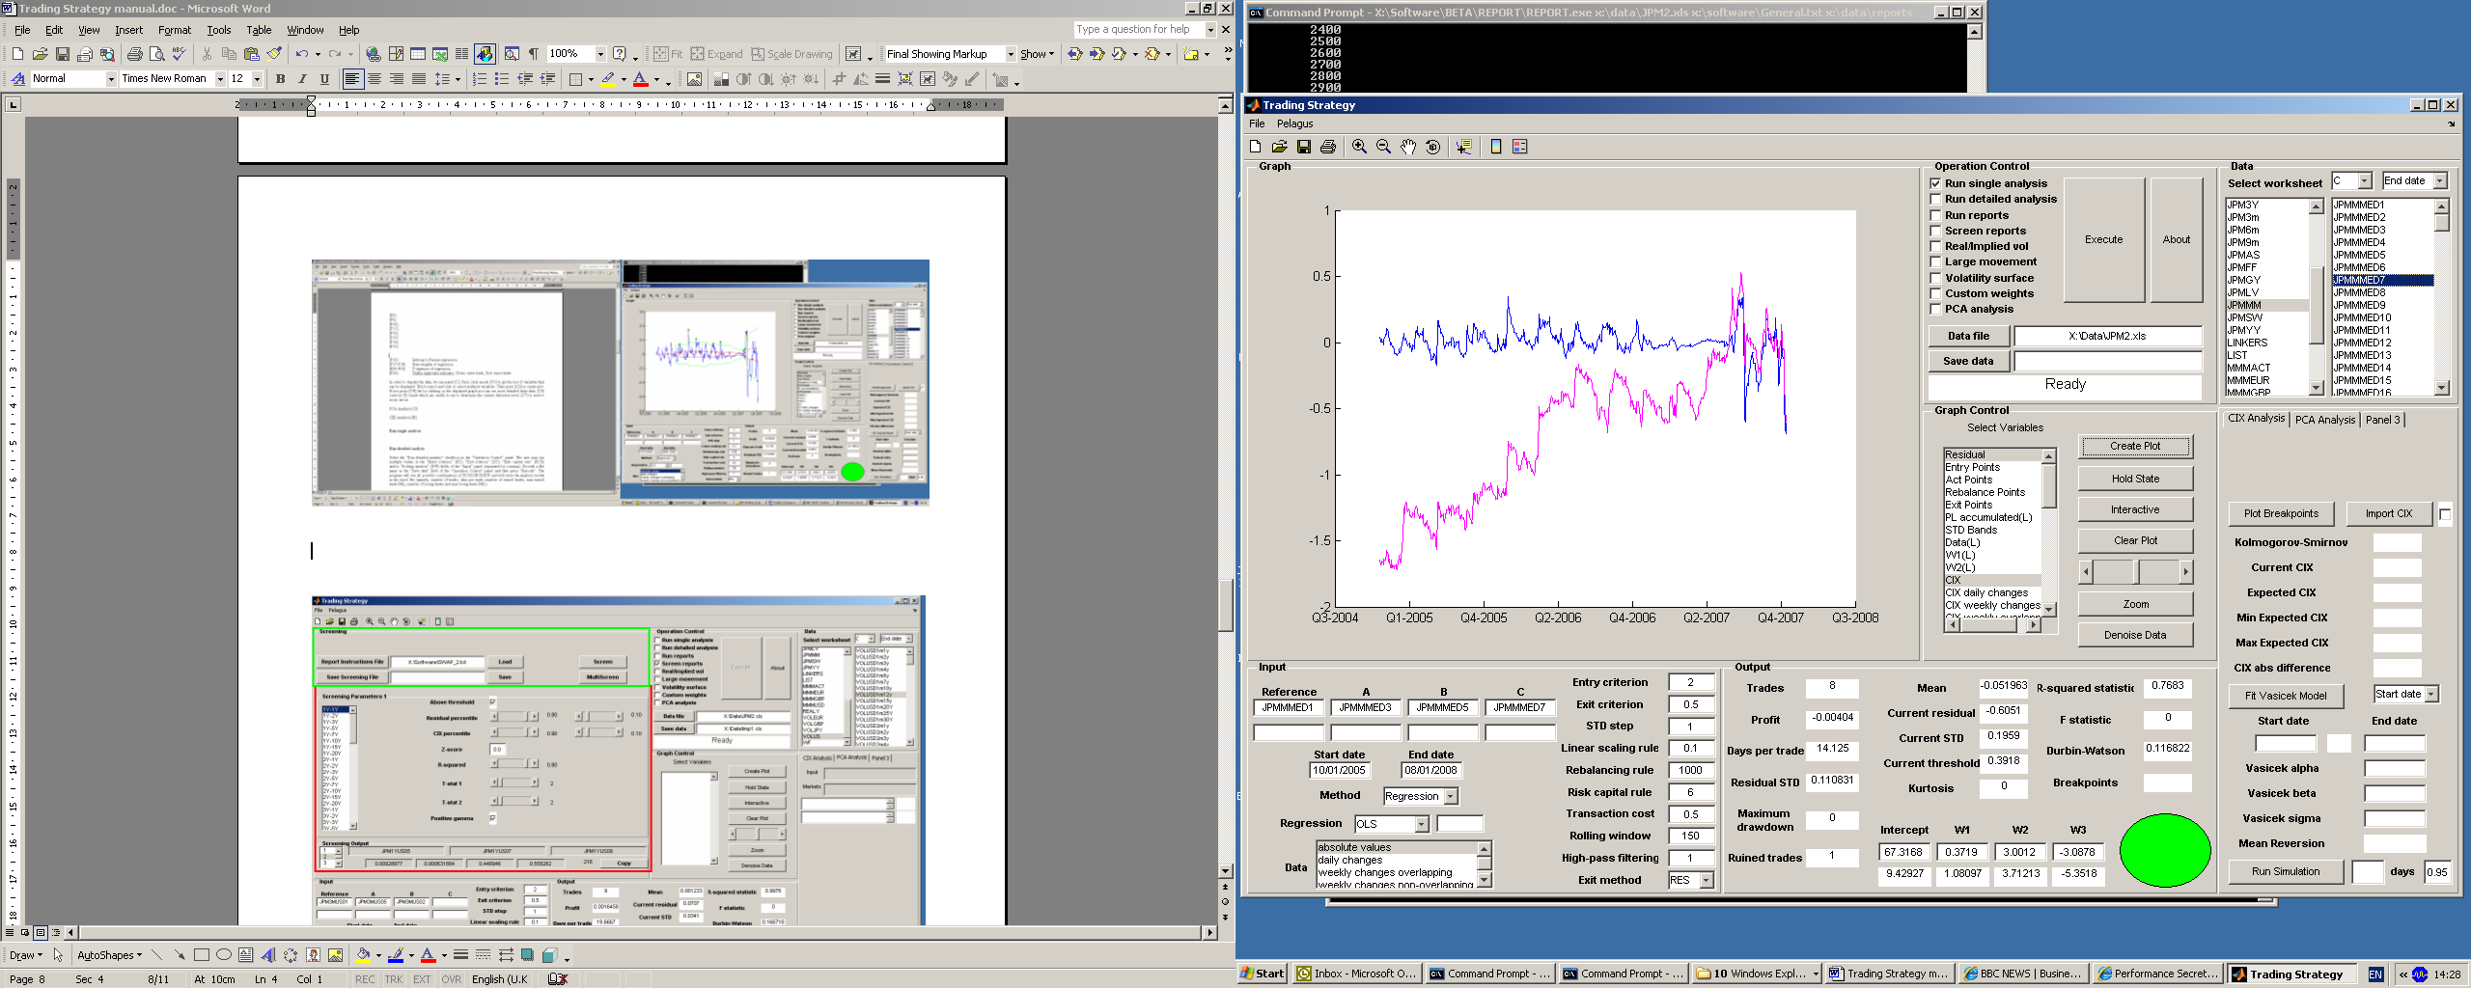

Figure 2: Single Analysis

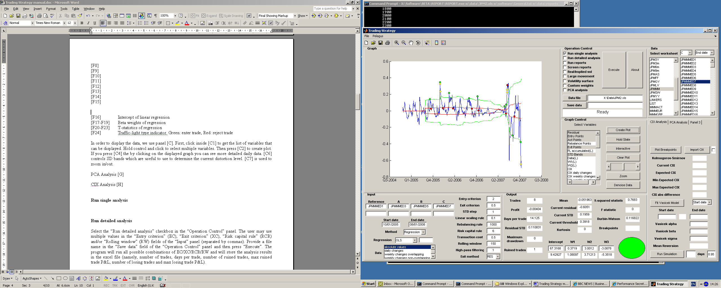

Figure 3: Single Analysis

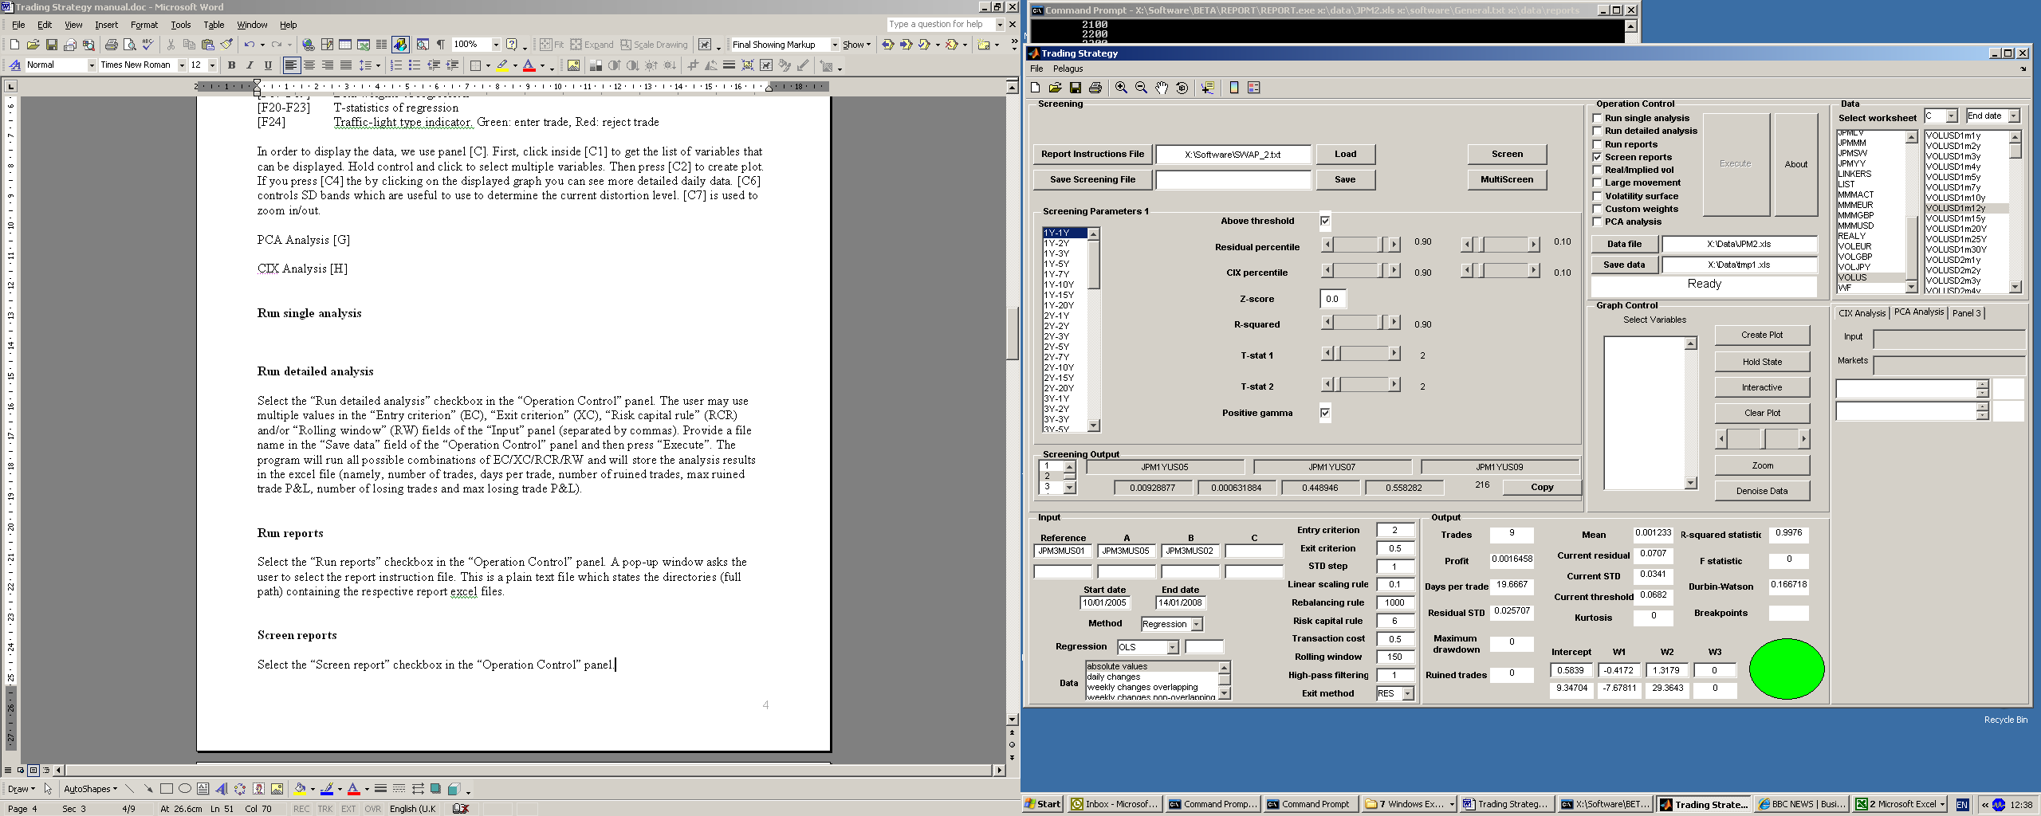

Figure 4: Screening and Screening Parameters 1

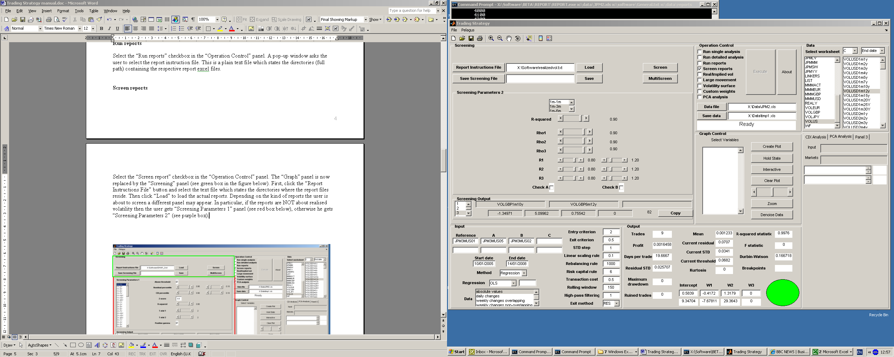

Figure 5: Screening Parameter 2 (for Realised Vol Reports)

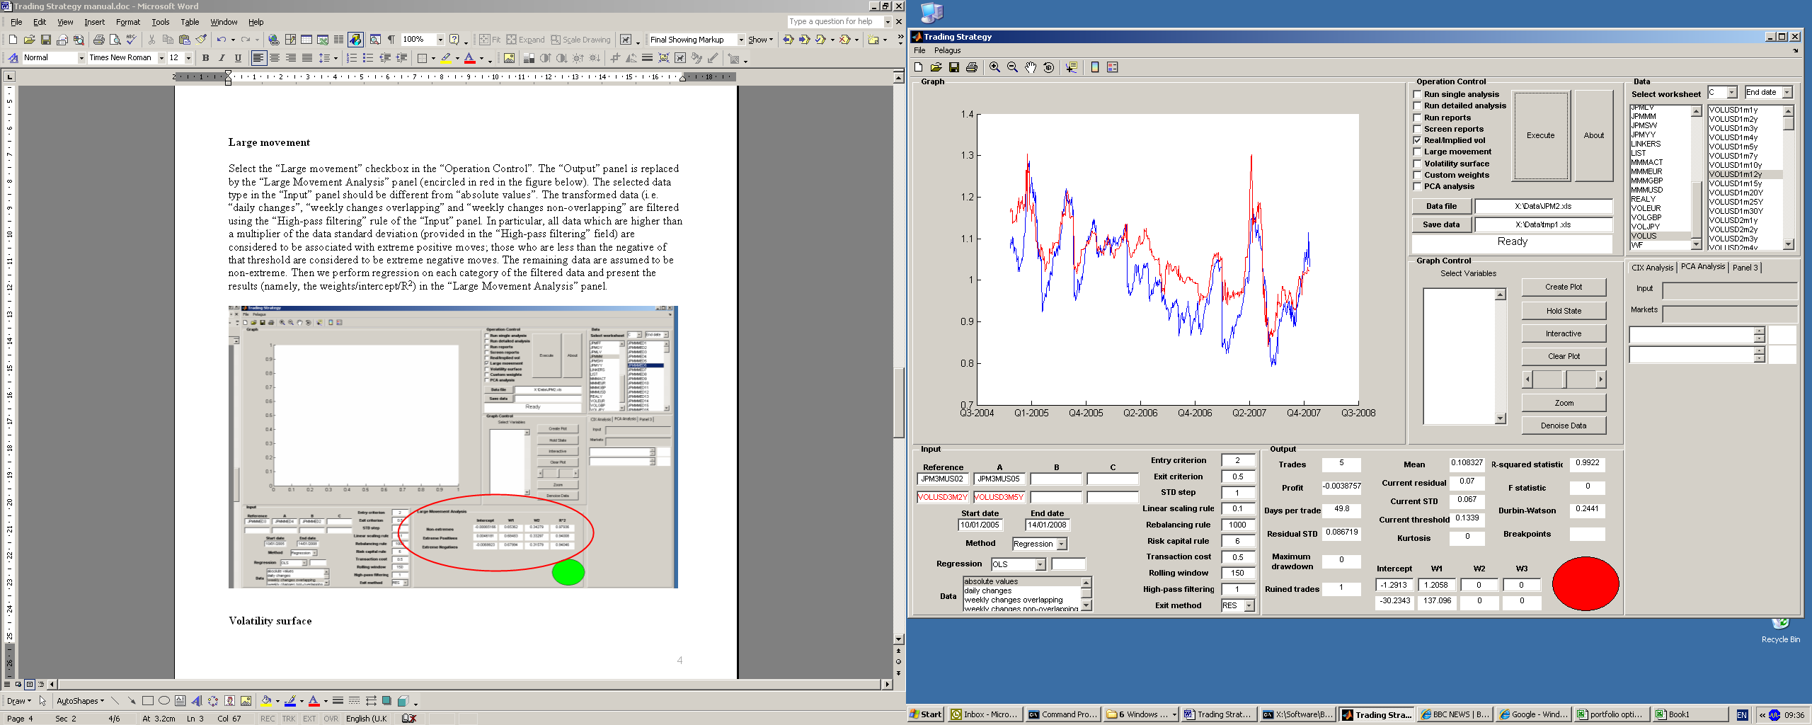

Figure 6: Realised/Implied Vol

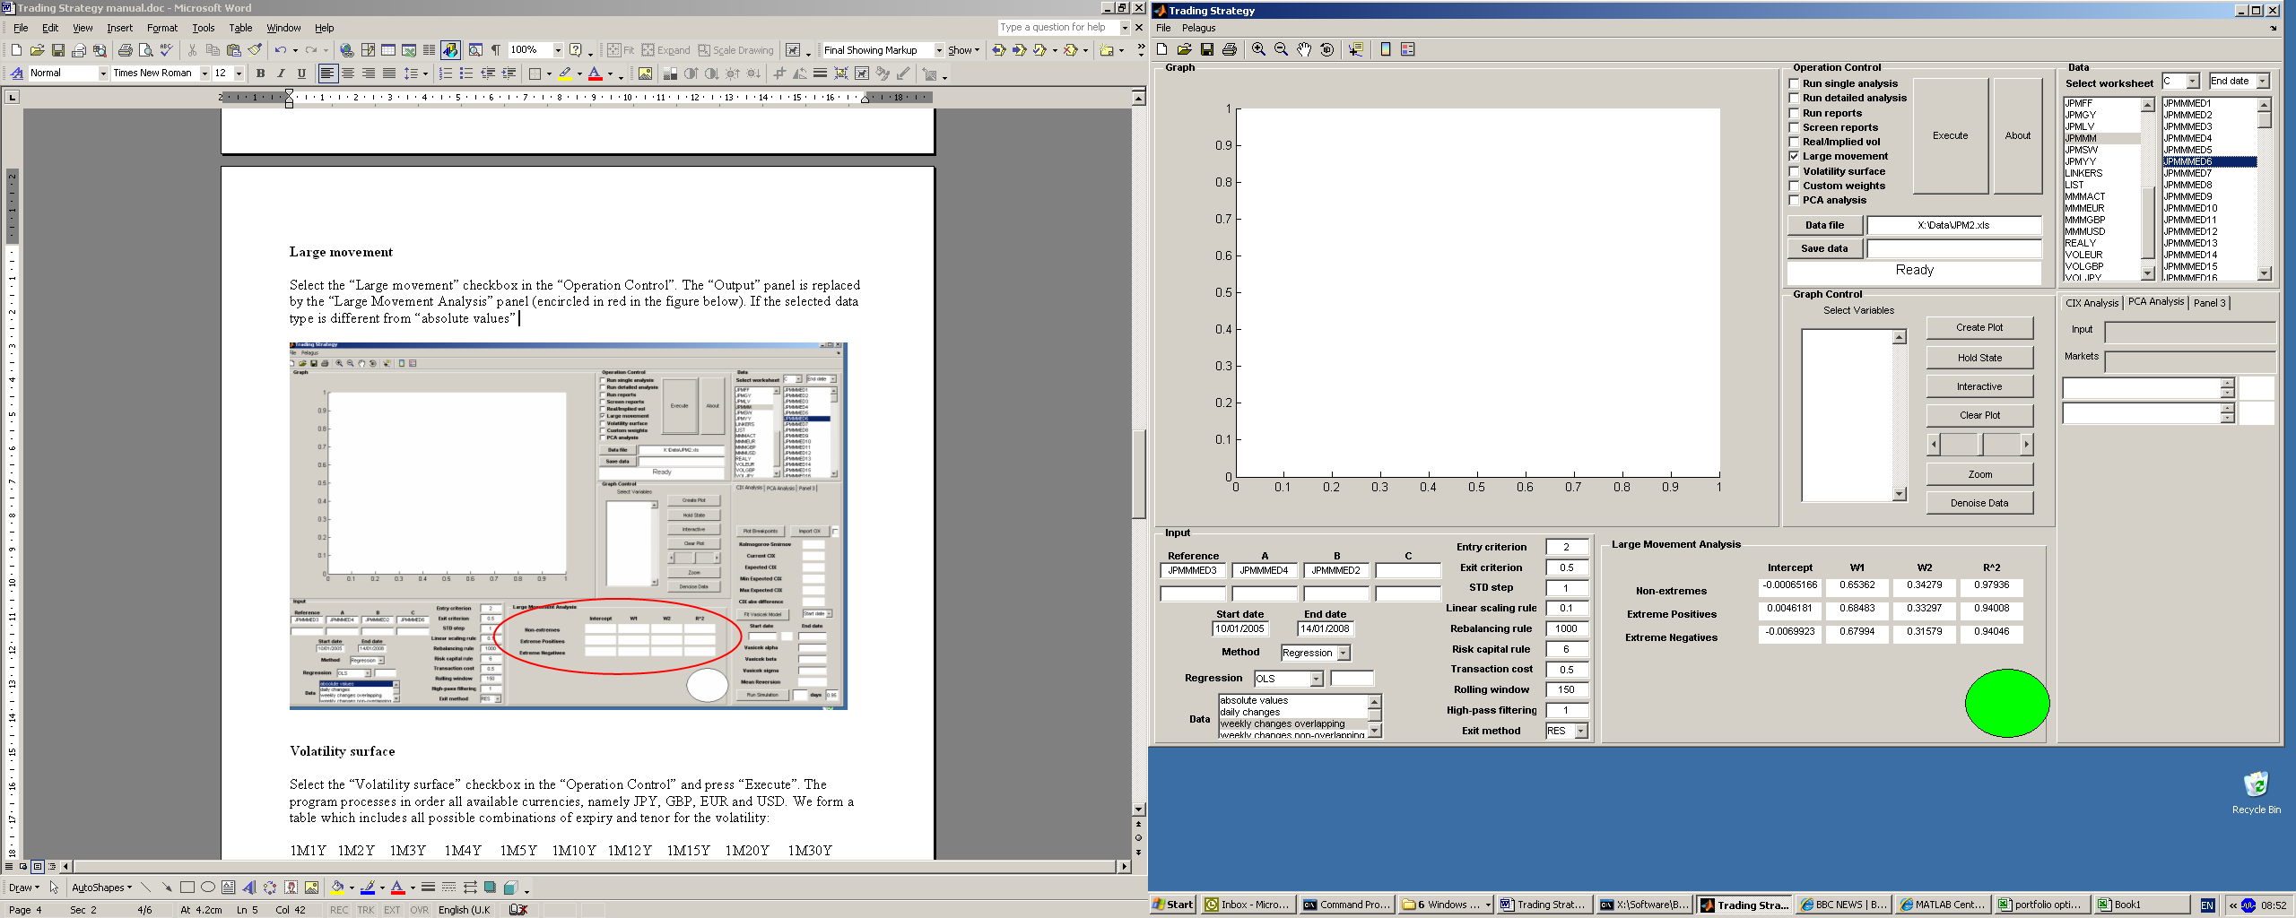

Figure 7: Large Movement

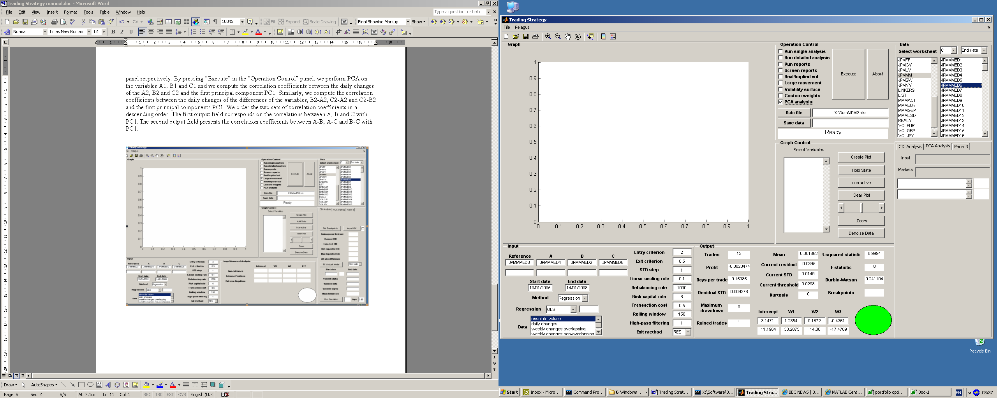

Figure 8: PCA Analysis

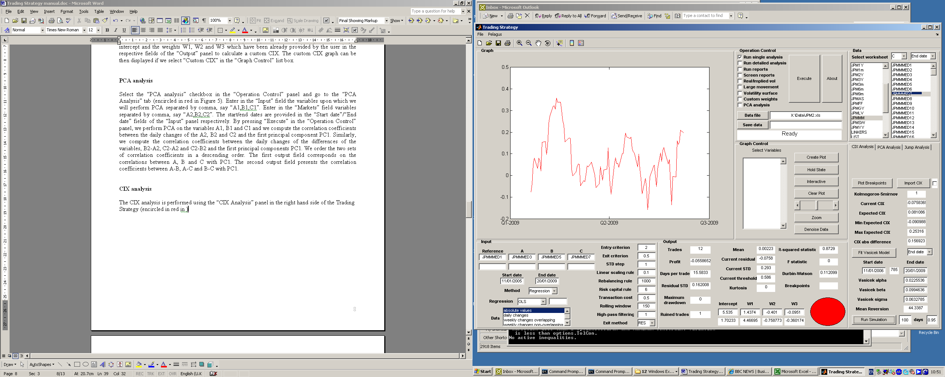

Figure 9: CIX Analysis

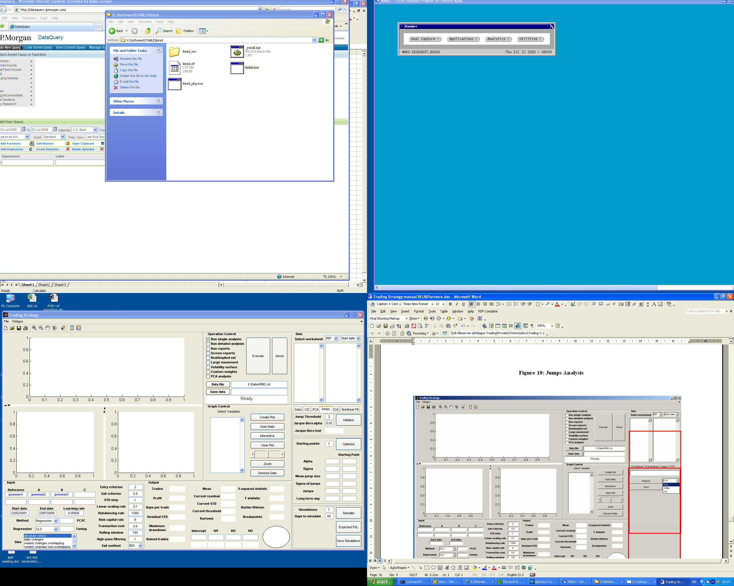

Figure 10: Jumps Analysis

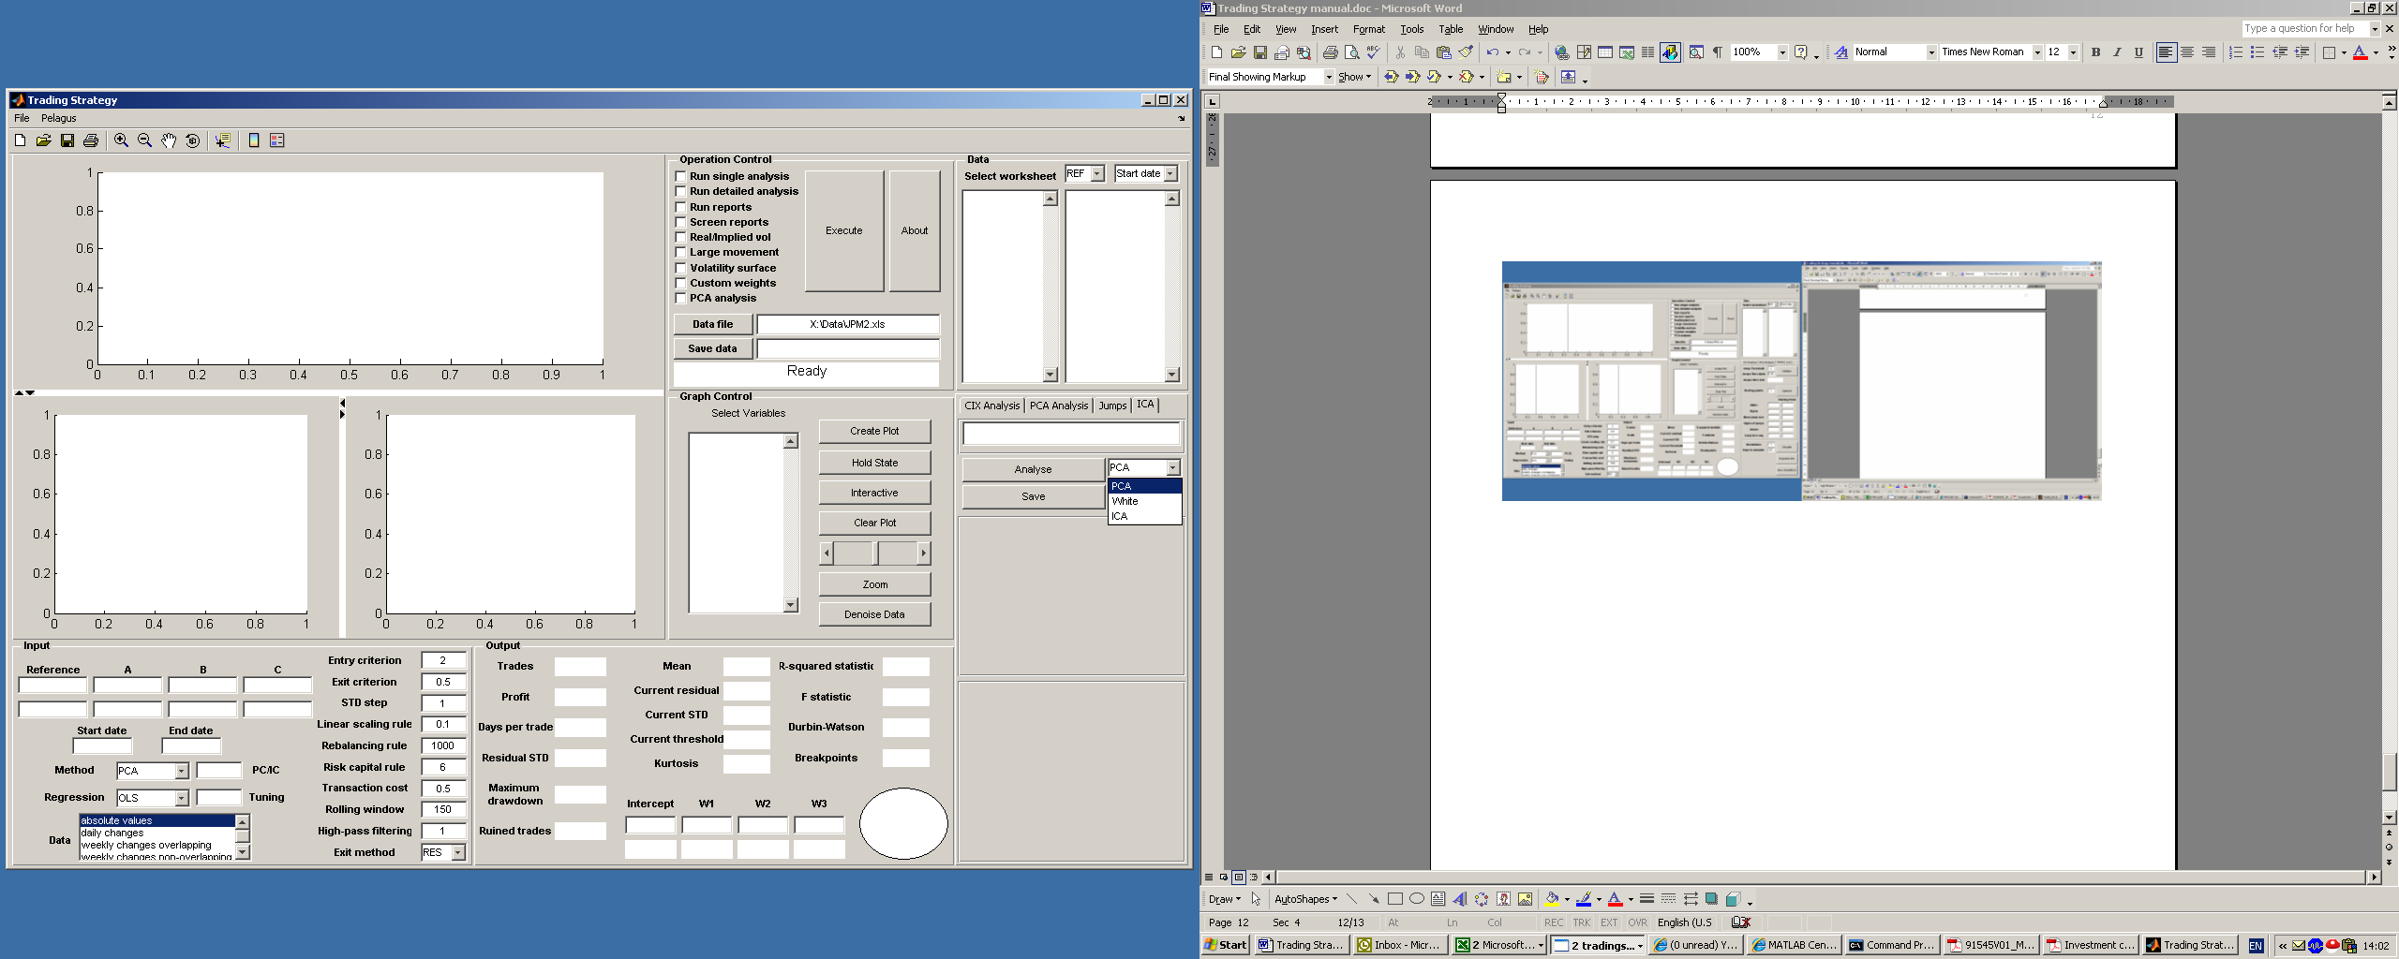

Figure 11: ICA Analysis

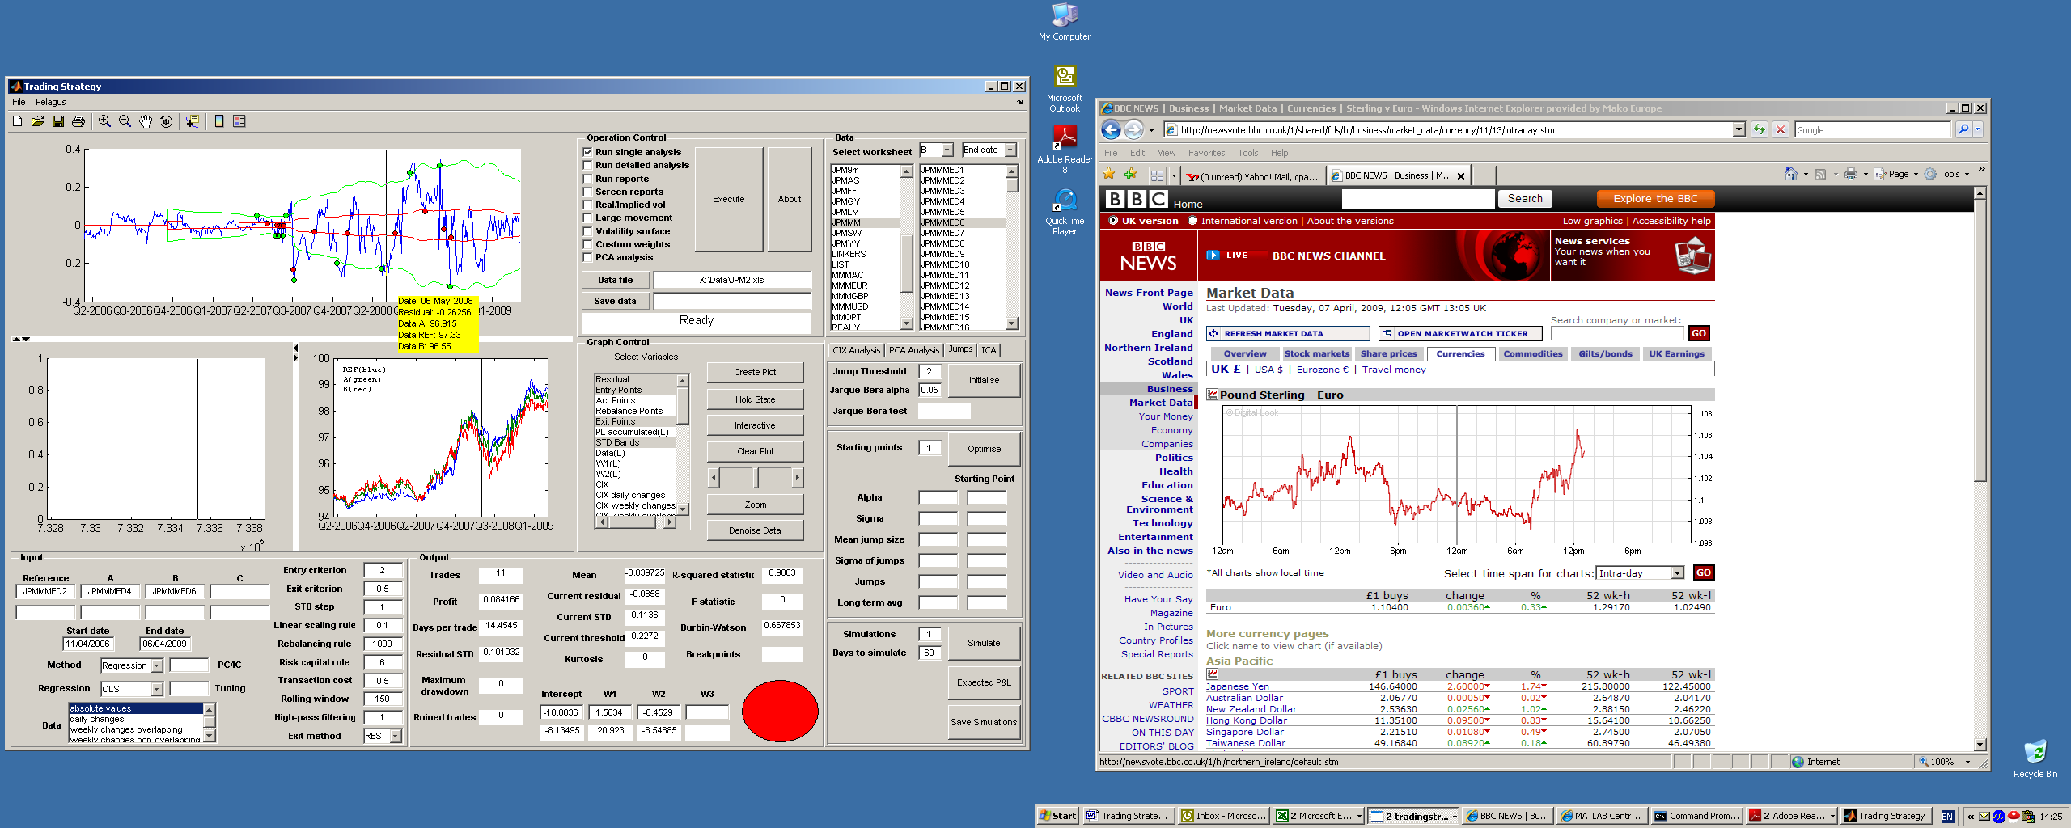

Figure 12: Main Screen

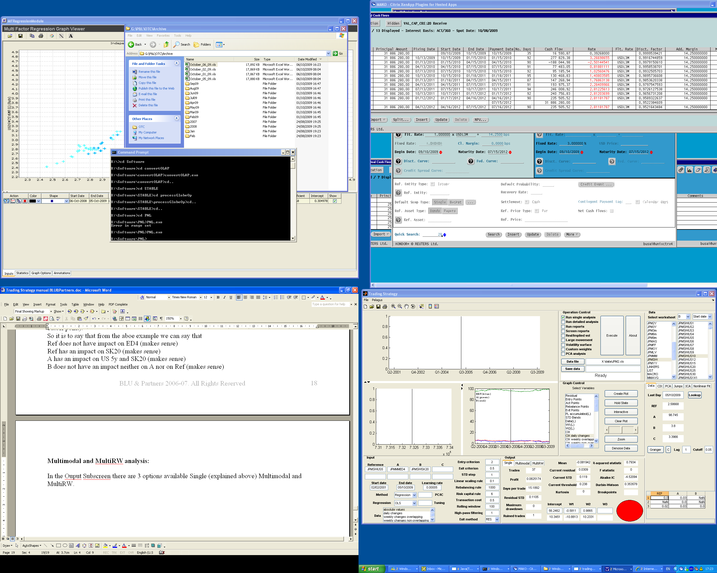

on the Multimodal one

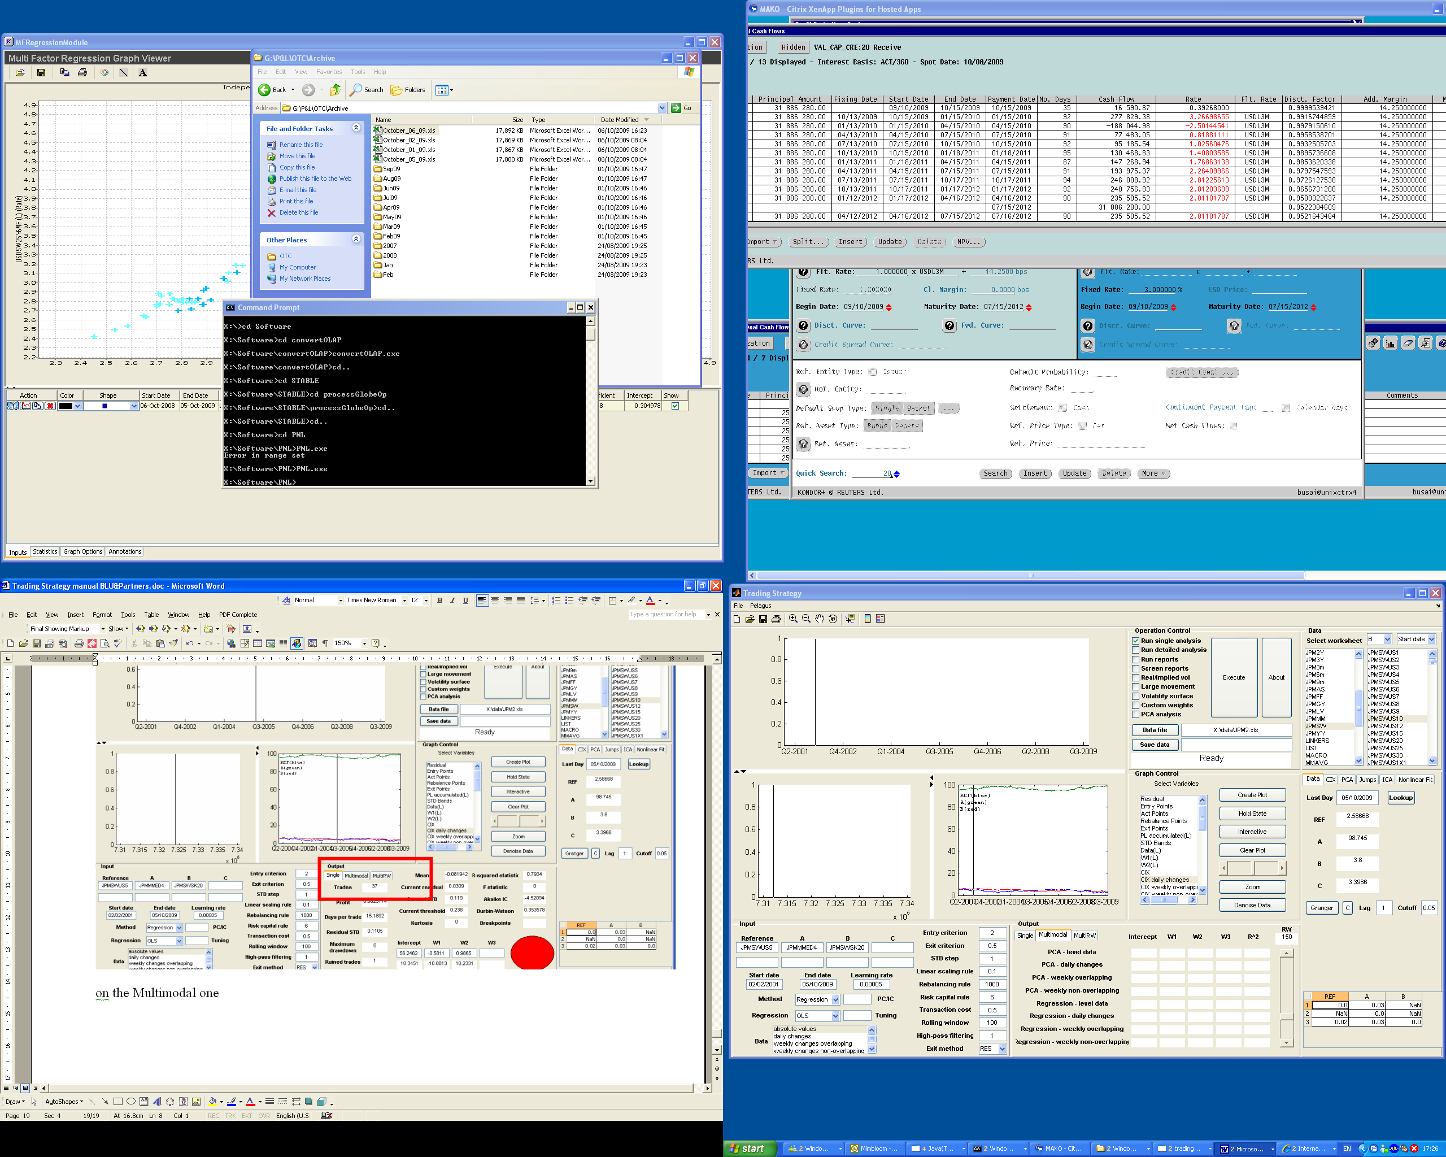

gives you the opportunity for any given time horizon (you can select with the slider on the left side of the scree) to see the Betas/Intercept and R^2 obtained by using 8 different methodology on Level and changes.

With the MultiRW one

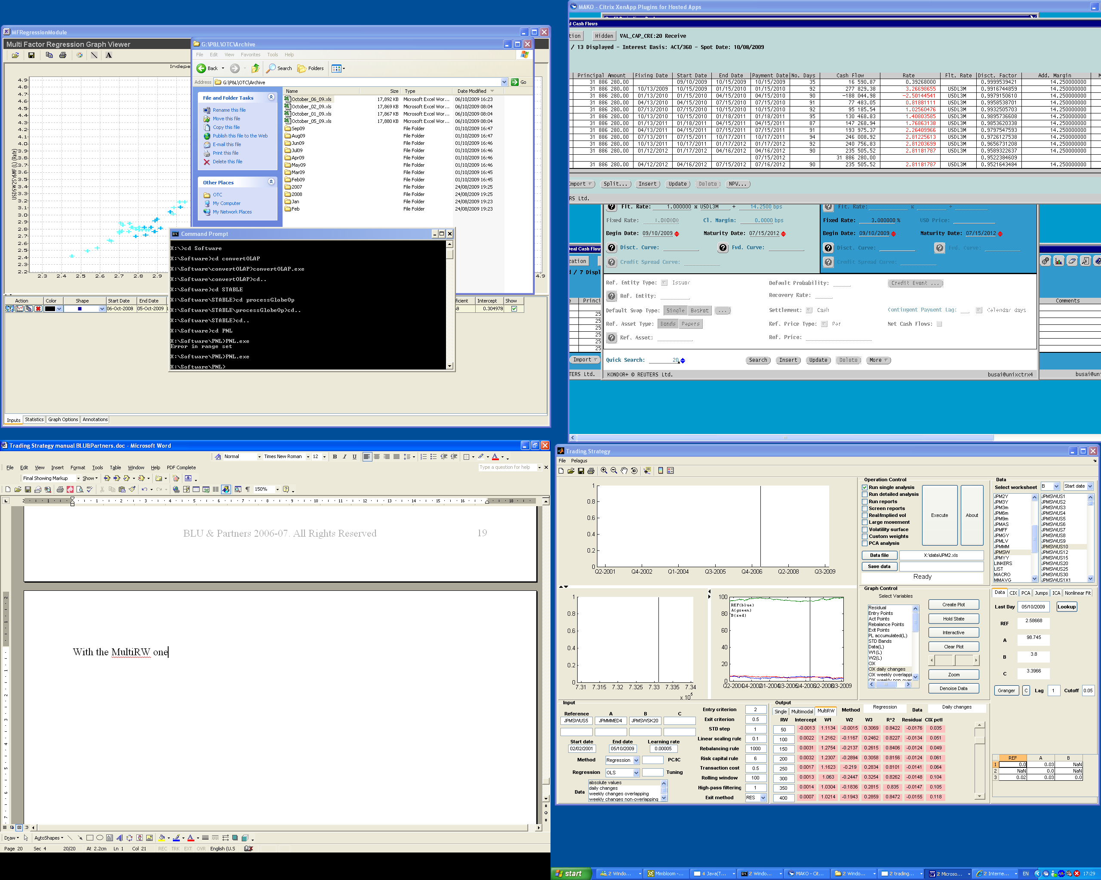

gives you the opportunity to check immediately the stability of the parameters obtained running 1 of the 8 methodology shown above (you can select the methodology by scrolling the slider on the left) on different time horizons and also one of the output is the CIX which allow you to pick up immediately the most extreme combination. The color of every single cells indicates if the combination is above (would have been green) or below the threshold (red like it is above).